## Introduction to SharePoint Designer 2010

**Lab Time**: 70 minutes

**Lab Overview:** In this lab you will be introduced the SharePoint Designer 2010 application. You will explore how to navigate a SharePoint site's components and modify them as needed. You will also learn how to manage security of a SharePoint's site using SharePoint Designer.

### Exercise 1: Looking Around SharePoint Designer 2010

In this exercise you will start exploring the SharePoint Designer 2010 environment.

1. Start SharePoint Designer: **Start » All Programs » SharePoint » Microsoft SharePoint Designer 2010**.

The first thing you see is what is called **Backstage**. The backstage page is the place where you can open up existing sites or you can create new sites. On the right side of the screen, you can see the templates that are located here. You can choose any of the templates, for example, the **Blank Site** template, the **Blog** template, the **Team Site** template or you can Click the **More Templates** icon to give you examples of more templates. You can use any of these templates to start creating your site. You can also click the **New Blank Web Site** button which will let you make a blank SharePoint site. On the left of the screen, you have the **Open Site** button. If you click the **Open Site** button, it gives you an **Open Site dialog box** in which you can open up an existing site. SharePoint Designer 2010 can be used to make any number of subsites under a top level site. SharePoint Designer 2010 cannot be used to make a site collection or a top level site.

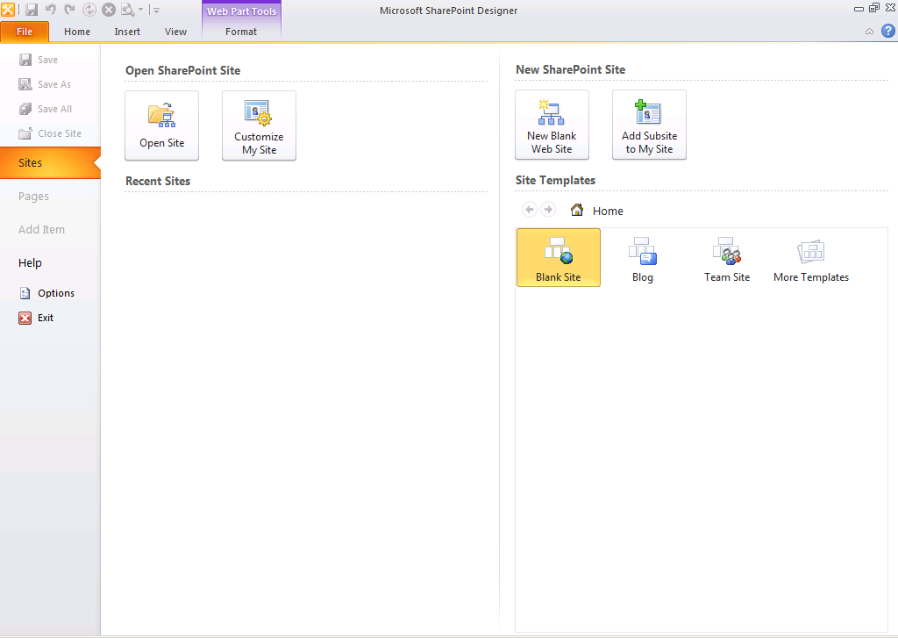

1. To start creating a new site, first you will go ahead and open up the top level site, Click the **Open Site button** and enter **http://intranet.wingtip.com**, which is the location for the top level site. Click the **Open** button and that will initiate communication with SharePoint in the backend and open up the top level site.

First notice the navigational components of SharePoint Designer 2010. On the left, you have the **Navigation pane.** In the navigation pane, you have all the different components for the site you are looking at right now.

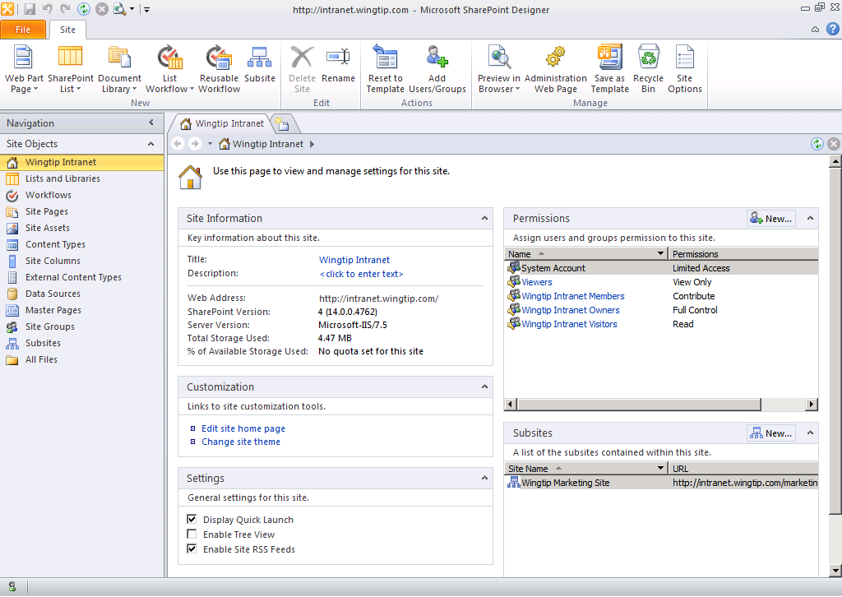

1. First it shows you the site's name itself, second it shows you the **Lists and Libraries** section, the **Workflows**, **Site Pages**, etc.
2. On the top you see the ribbon. The ribbon has been made prevalent all through 2010 SharePoint and Office 2010 clients. The ribbon shows you the different actions you can take depending on which object you are looking at right now.
3. Since you are on the **http://intranet.wingtip.com** top level site, it states you can make a **Web Part Page**, **SharePoint List**, **Document Library**, etc.
4. In the middle of the page you have the **Summary page**. Currently it is showing the **Site Information** in one section, **Customization** in the second, **Settings** in the third one, **Permissions** and then **Subsites**. These sections show the different components of the site.
5. Click various things in the navigation pane such as **Lists and Libraries**, **Workflows**, etc, to see how the ribbon changes depending on where you are.
6. Select **Site Pages** in the Navigation Pane and you will see that there are two pages in the Site Pages library: Home.aspxand How To Use The Wiki Library.aspx. The Home.aspx page serves as the main home page for the site.
7. Click the Home.aspx page, now it shows you the **Summary Page** for the Home.aspx page. It shows the **File Information** for Home.aspx, the **Customization** section where you can click the **Edit File** link to customize the Home.aspx page, it shows you the **Permissions** for the Home.aspx page, and if there are **Versions** of this page, it will show you in the version history section.
8. Click the **Edit File** link under the **Customization** section. Since SharePoint Designer 2010 is a WYSIWYG (what you see is what you get) tool, it shows you the home page of this site the way you would see it in the browser. You can manage the text, images and other components of this page directly from here.

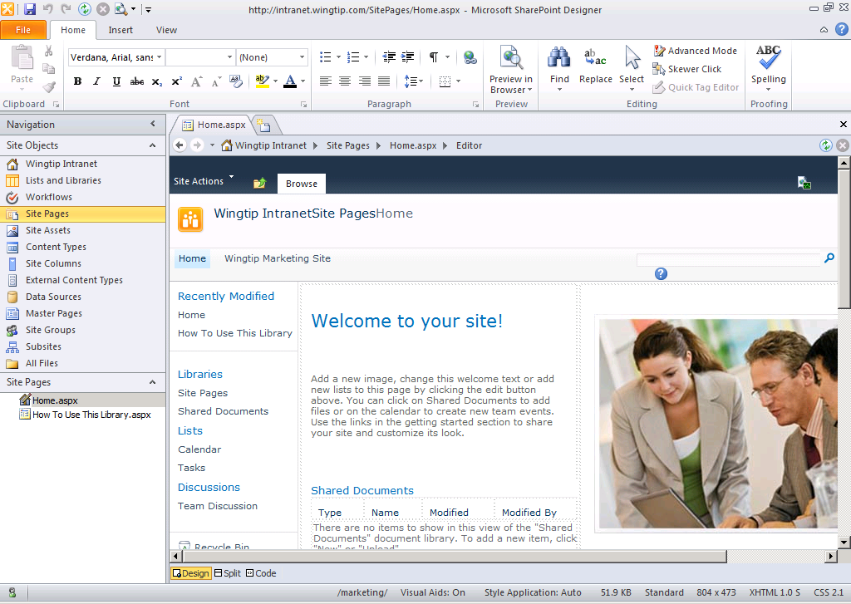

1. If you look at the top of the page and try to click the title of the page, you should not be able to click it because that is locked down for this page. Same thing is the case for the **Quick Launch** or the site navigation for this home page, you should not be able to click that either. You will not be able to make any changes to the home page at this time. In another module, you will be making changes to the pages of the site.
2. Click the picture on the page. Notice that in the ribbon the **Picture Tools** contextual tab appears. If you click the **Format** tab under **Picture Tools**, it lets you see all the different actions you can take on the picture.

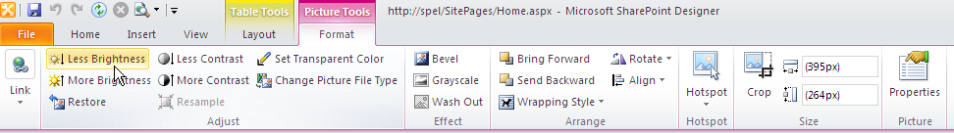

1. Click anywhere in the content of this page. You will see the **Table Tools** contextual tab. If you click the **Layout** tab under **Table Tools** contextual tab group, it will let you make any modifications to the table and that has been laid out on the page.

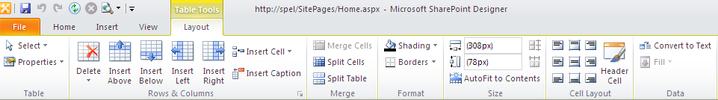

1. In the navigation pane of the SharePoint Designer, click the **Lists and Libraries** link. You will see all the lists and libraries listed here, the ones that came out of the box when this site was created such as **Announcements**, **Calendar**, **Links**, **Tasks**, etc.
2. Click the **Links** list. Notice that you see information about this list in the summary page.
3. The first thing that you see is the **List Information** section, which shows you the **Name** and **Description**, among others details on the list. It also shows you the **Views** section, which has all the views listed for the list. Currently there is only one view called **All Links** view. Also shown is the **Forms** section, the Forms section shows three forms that exist that to create new list items, to edit items and to display items in this list.

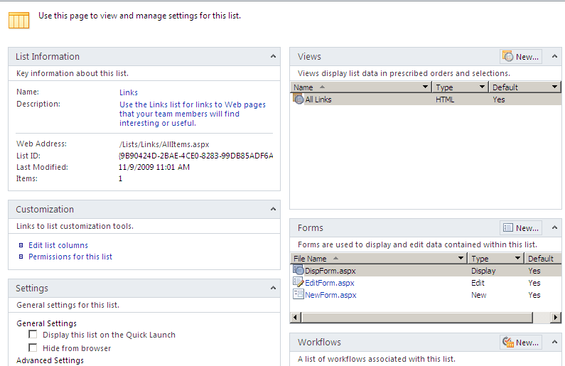

1. Below that there is a **Workflows** section. The Workflows section shows any workflows associated with the list.
2. There is also a **Content Types** section, which would show any content types associated with this list.
3. There is a **Custom Actions** section. The Custom Actions section would show any custom defined actions that can be taken on this list. You could add Custom Action buttons to the SharePoint ribbon and also options to the List Item menu using this functionality.

In this exercise you walked through the basic SharePoint Designer 2010 interface.

### Exercise 2: Creating Custom Actions

In this exercise you will create a couple of Custom Action buttons. The first one is going to show the DisplayForm for list items and the second one is going to show the Edit Formfor the item.

1. Select **Lists and Libraries** in the Navigation Pane.
2. Select the **Links** list.
3. Click the **New** button in the **Custom Actions** section, the **Create Custom Action** dialog box should come up to ask you the **Name** and **Description** of this custom action and also what would you like to do when this action is clicked. Use the following information to complete the dialog box:

**Name:** Display Form

**Select the type of Action:** Navigate to form » DispForm.aspx

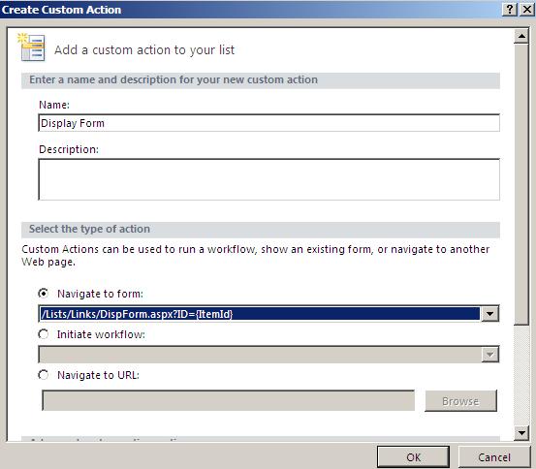

1. Click the **New** button again in the **Custom Actions** section and use the following information to complete the dialog:

**Name**: Edit Form

**Select the type of action**: Navigate to form » EditForm.aspx

1. With the custom actions created, it is time to test them. Open the browser and navigate to the top level SharePoint site. From the home page of the site, click the **All Site Content** link in the **Quick Launch** bar. Select the **Links** list you will make a new link here.
2. Select **Add New Link** and click use the following information to create a new link:

**URL:** http://www.CriticalPathTraining.com

**Description:** Critical Path Training

1. Now that you have a link in the **Links** list, to see the custom actions that you had created earlier, hover over the link, click the drop-down for the list item menu. You should see the **Display Form** and the **Edit Form** links.

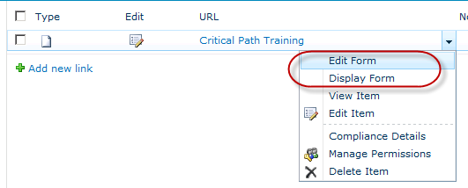

1. Click the **Display Form** link. This should take you to another page to show you the DisplayForm.aspxfile.
2. Click the back button in the browser, hover over the SharePoint related information link again, and this time click the **Edit Form** link from the drop-down. This should show you now the EditForm.aspxfile.

In addition, custom actions can be used to initiate a workflow or to navigate to a predefined URL.

In this exercise you created two custom actions on an existing SharePoint list.

### Exercise 3: Discovering Master Pages

In this exercise you will discover the various master pages that come with SharePoint. Master pages provide the chrome, branding, logo, navigation and style of pages within a SharePoint site.

1. Open **SharePoint Designer 2010** and open the **http://intranet.wingtip.com** site using the same steps in a previous exercise
2. Click the **Master Pages** link in the **Navigation Pane**. This will list the Master Pages available for this site.

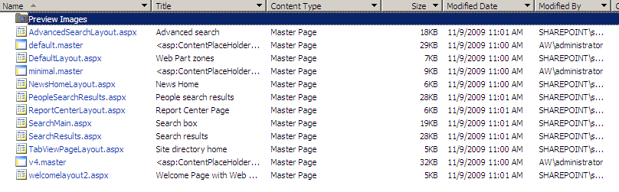

The **v4.master** master page is the one that is used to provide the chrome and navigation for this site. The **minimal.master** which is provided if you wanted to start using a minimal master page and build up from it.

The **default.master** page that was used in the previous versions of SharePoint and can still be used if you wanted SharePoint 2010 to look and feel like SharePoint 2007. This is primarily included for backwards compatibility and to simplify upgrades.

1. Click the **v4.master** link to load the **Summary Page** of v4.master.
2. Click the **Edit File** link, you will now see the chrome of the page, the top link bar, the title, the search box and also the quick launch menu. Everything is editable. Feel free to click around on different places here, making sure not to change any of the components at this time. Any changes that you make to this page right now will take effect all throughout the site.

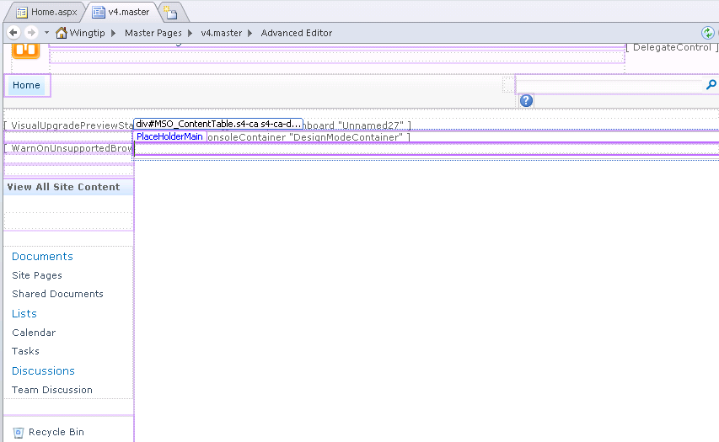

1. To see all the files and artifacts that are in this site, click the **All Files** link in the Navigation Menu at the bottom. You will see here that all of the different files, folders, libraries and pages that exist on this site are displayed in this view.
2. Click **_catalogs** folder and then click the **masterpage** folder. You should see the contents of the Master Page Gallery which shows you all the folders that we saw earlier in the **Master Pages** section of the Navigation Menu.

Keep in mind that the **All Files** section can be used to find information that you need on the site or you can simply use the Navigation Menu provided within SharePoint Designer to easily get to the components of the site.

In this exercise you took a look at the details around Master Pages in SharePoint Designer 2010.

### Exercise 4: Managing Site Permissions

In this exercise you will see how security is managed for a SharePoint site directly through the SharePoint Designer environment.

1. Click the **Wingtip Intranet** link from Navigation Pane of SharePoint Designer 2010.
2. Look at the **Permissions** section of the summary page. It shows all the different people and groups who currently have permissions on this site and also displays which permissions they have.
3. Click the **New** button in the Permissions section. It gives you the Add Permissionswindow. In the window you can type in the user name, group name or email addresses directly for people in organizations and then select which SharePoint group do you want to add these people to. If you want to give them permissions directly, you can do that as well.

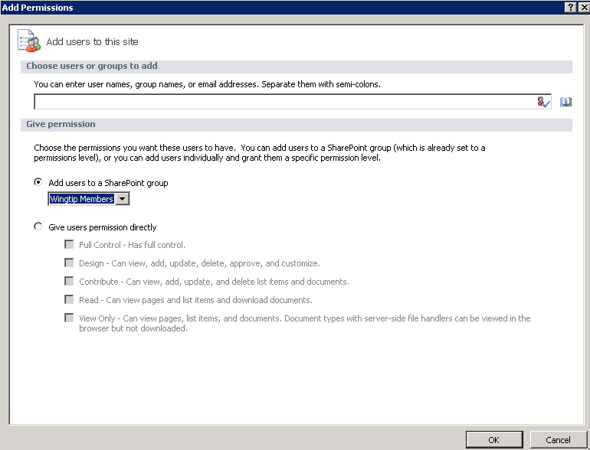

* 1. Click the **Address book** icon. From the SharePoint contacts lookup window, type in **domain** and click the **search icon**. It should bring back multiple groups with the word domain in it.
  2. Click the **WINGTIP\domain users** display name, click the **Add** button, then click the **OK** button.

1. Once at the **Add Permissions** window, select **Wingtip Intranet Members** in the drop-down and click the **OK** button. A dialog box pops up asking you if you want to see the membership of this group. Click **Yes**.
2. It will navigate you automatically to the **Site Groups** Navigation Pane, showing you the members of the **Wingtip Intranet Members** group. In the breadcrumb trail, notice that that **Wingtip Intranet Members** is the one that is highlighted. The **Members** right now shows **WINGTIP\domain users**, meaning all domain users have now been added as members of this site of the site collection.
3. To verify this, open the browser, browse to the Wingtip Intranet site and select **Site Actions » Site Permissions** link. You should now see all the different groups and their permissions levels for this site.

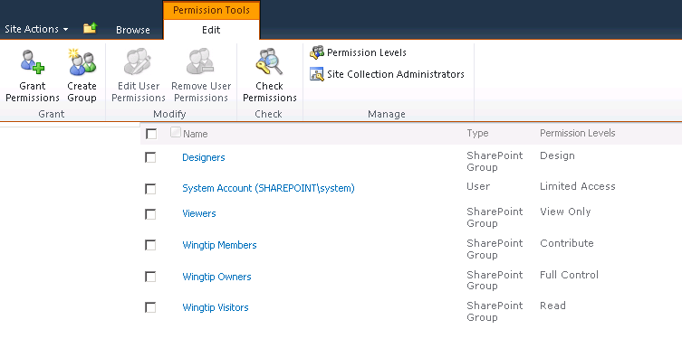

1. Click the **Wingtip Intranet Members** group. You should see the **WINGTIP\domain users.**
2. Click the **Home** link in the top navigation to get back to the home page of this site.
3. Now you are going to login as another domain user to see if you can log in successfully.
4. Select **WINGTIP\administrator** **» Sign in as Different User**. From the windows security dialog box that appears, select **Use another account**. Login using the account **WINGTIP\ken** (Ken Sanchez).
5. Sign back in as the **WINGTIP\administrator** by using the same method: **Ken Sanchez** **»** **Sign in as Different User.**
6. You will now create a new SharePoint group and assign it the **design** permission. These will be the designers of the site collection.
7. Click the **Site Groups** link in the Navigation Pane of SharePoint Designer.
8. Click the **New Group** button on the ribbon on top. Use the following information to create a new group:

**Name:** Designers

**Set the Group Owner:** WINGTIP\administrator

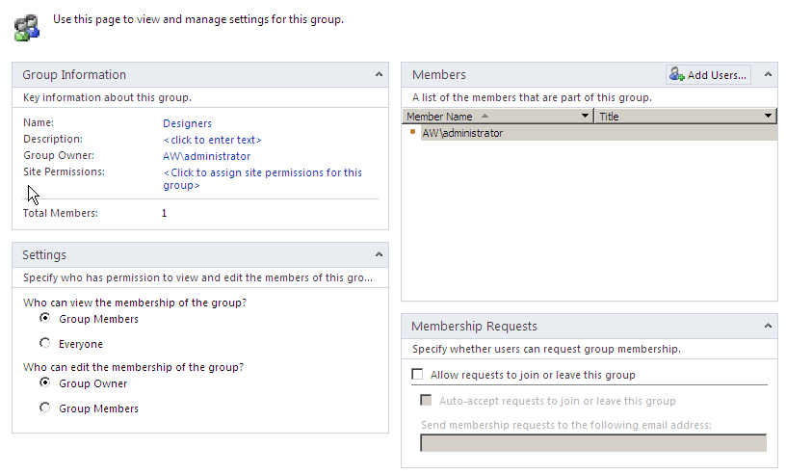

1. By the label **Site Permissions** under the **Group Information** section, click the link which says **Click to assign site permissions for this group**.
2. From the **Edit Permissions** dialog box that appears, click the **Design** check boxand click **OK**.
3. Now add a few members to this SharePoint group. From the **Members** sectionof this **Summary Page**, click the **Add Users** button and use the following information to add some users:

**Choose users to add:** WINGTIP\ken (click the person check icon to validate the user)

1. Repeat the process to add **WINGTIP\jill** (Jill Williams).
2. **Ken Sanchez** and **Jill Williams** have now been added to the SharePoint Designers group.

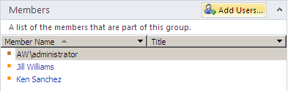

In this exercise you managed the site permissions via SharePoint Designer 2010.

### Exercise 5: Restricting SharePoint Designer Usage

In this exercise you will explore the ways in which a site collection administrator can restrict usage of SharePoint Designer to certain groups of people within the organization.

1. Using the browser, navigate to the top level **Wingtip Intranet** site. Click **Site Actions »** **Site Settings.**
2. Under the **Site Collection Administration** group, click the **SharePoint Designer Settings** link.

You see over here that by default SharePoint Designer is enabled for **Designers** and **Site Owners** of the sites in the site collection. What is not enabled is **Detaching Pages from the Site Definition**, **Customizing Master pages** **and Layout Pages** and **Managing of the Web Site URL Structure**.

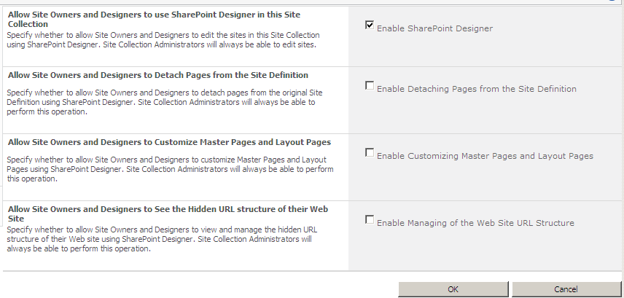

1. Click **Cancel**.
2. **Minimize all windows** to go to the desktop.
3. Login as Janice Galvin:
4. From the Start menu, launch the Remote Desktop Connection client: **Start » All Programs » Accessories » Remote Desktop Connection**.
5. When prompted for the computer name, enter **WINGTIPSERVER**.
6. When prompted for the username & password, use Janice’s credentials.
7. Once you are logged in launch SharePoint Designer: **Start » All Programs » SharePoint » Microsoft SharePoint Designer 2010**
8. In SharePoint Designer 2010, click the **Open Site** button to open **http://intranet.wingtip.com**. Since Janice is not a designer or a site administrator, she the following dialog box:

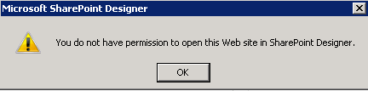

1. Log off Janice by clicking on **Start** button and then Log off.
2. Now, login as **Ken Sanchez** (WINGTIP\ken), launch SharePoint Designer 2010 and open the same site. Ken should be allowed to get into the SharePoint Designer environment because he does have permissions currently to open up a site in SharePoint Designer.

There are a few things that Ken is not able to do as a designer. Master pages cannot be customized or altered. Notice there is no master page link in the Navigation Pane of the SharePoint Designer. The Web site URL structure cannot be modified. The **All Files** link that appears for the administrator as you saw in the lab does not exist in navigation pane for Ken.

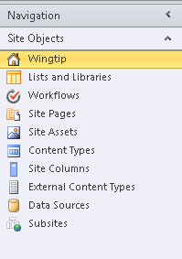

1. Click **Site Pages** in the Navigation Pane.
2. Click the Home.aspxlink. In the ribbon, click **Edit File** drop down menu.Notice that only **Edit File in Normal Mode** is present; **Edit File in Advanced Mode** is disabled because designers are not allowed to detach pages from site definition which is what the Advanced Mode would do.

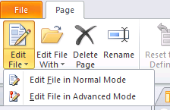

1. To enable these three functionalities currently not present for designers, minimize the **Remote Desktop Connection**.
2. From the desktop of the administrator, open Internet Explorer and from the **Site Settings** page of the top level site, select **SharePoint Designer Settings** under the **Site Collection Administration.** Click the check boxes for **Enable Detaching Pages from the Site Definition**, **Enable Customizing Master pages and Layout Pages**, and **Enable Managing of the Web Site URL Structure** and click **OK.**
3. Go back to the remote desktop session for Ken Sanchez. Use the refresh icon at the top left to refresh SharePoint Designer.
4. Now while looking at the Home.aspxpage. Click drop down menu for the **Edit File.** The **Edit File in Advanced Mode** option should now be available.
5. Note that the **Master Pages** link is now available in the navigation link as well as the **All Files** link.

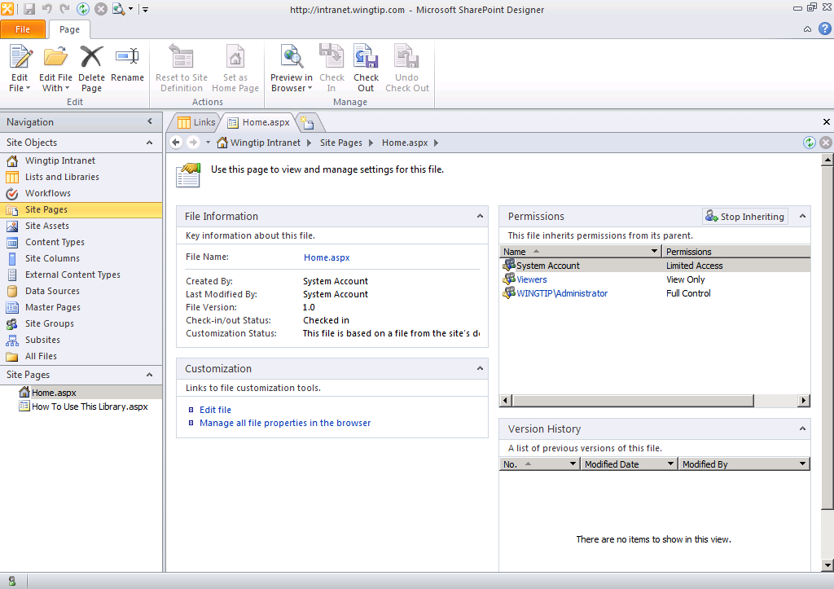

1. Log offthe remote desktop environmentfor Ken Sanchez.
2. Go back to the **SharePoint Designer Settings** under the **Site Collection Administration** section and **uncheck the check boxes** that you checked earlier leaving only the **Enable SharePoint Designer** check box checked. Click the **OK** button.

In this exercise you explored the different ways you can manage SharePoint 2010 by blocking and allowing the use of SharePoint Designer 2010.